Name: Harsh Rawte

Roll no: 22101A0047

Experiment 2: Automating Version Control and Code Collaboration of TE Mini Project with Git
Aim: To Perform Code Collaboration of TE Mini Project using GIT workflow
Problem:
TechCo’s development team is collaborating on a new feature for their application. However, multiple developers are working on the same parts of the codebase, causing merge conflicts, inconsistent commits, and errors in version control. The team struggles to manage branches effectively and maintain a clean history. The current workflow relies heavily on manual processes, making it difficult to track and resolve issues efficiently.
Implementation:
- Set up a Git repository for a project (either create a new project or use an existing one).
- Collaborate with a team member by creating multiple branches for different features.
- Implement the following:
  - Create a feature branch and make changes to the code.
  - Push changes to the remote repository.
  - Use a Git cheat sheet to commit, merge branches, and resolve conflicts.
  - Create a pull request (PR) and ensure code review processes are followed.

Step 1: Initialize a Git Repository and Push It to GitHub
1.1 Initialize a Git Repository Locally
- Navigate to your project directory on your local machine (or create a new project folder).
- Open your terminal and run the following command to initialize a Git repository:
git init
1.2 Add Files to the Repository
- Add a new file or make changes to existing files. For example, create a README.md file in the project folder:
echo "# My Project" > README.md
1.3 Stage and Commit Files
- Stage the files for commit using:
git add .
- Commit the staged files with a message:
git commit -m "Initial commit"

1.4 Create a GitHub Repository
- Go to GitHub and create a new repository. You can name it something like "Third-Year-Mini-Project".
- Copy the URL of the GitHub repository, e.g https://github.com/harshhrawte/Third-Year-Mini-Project
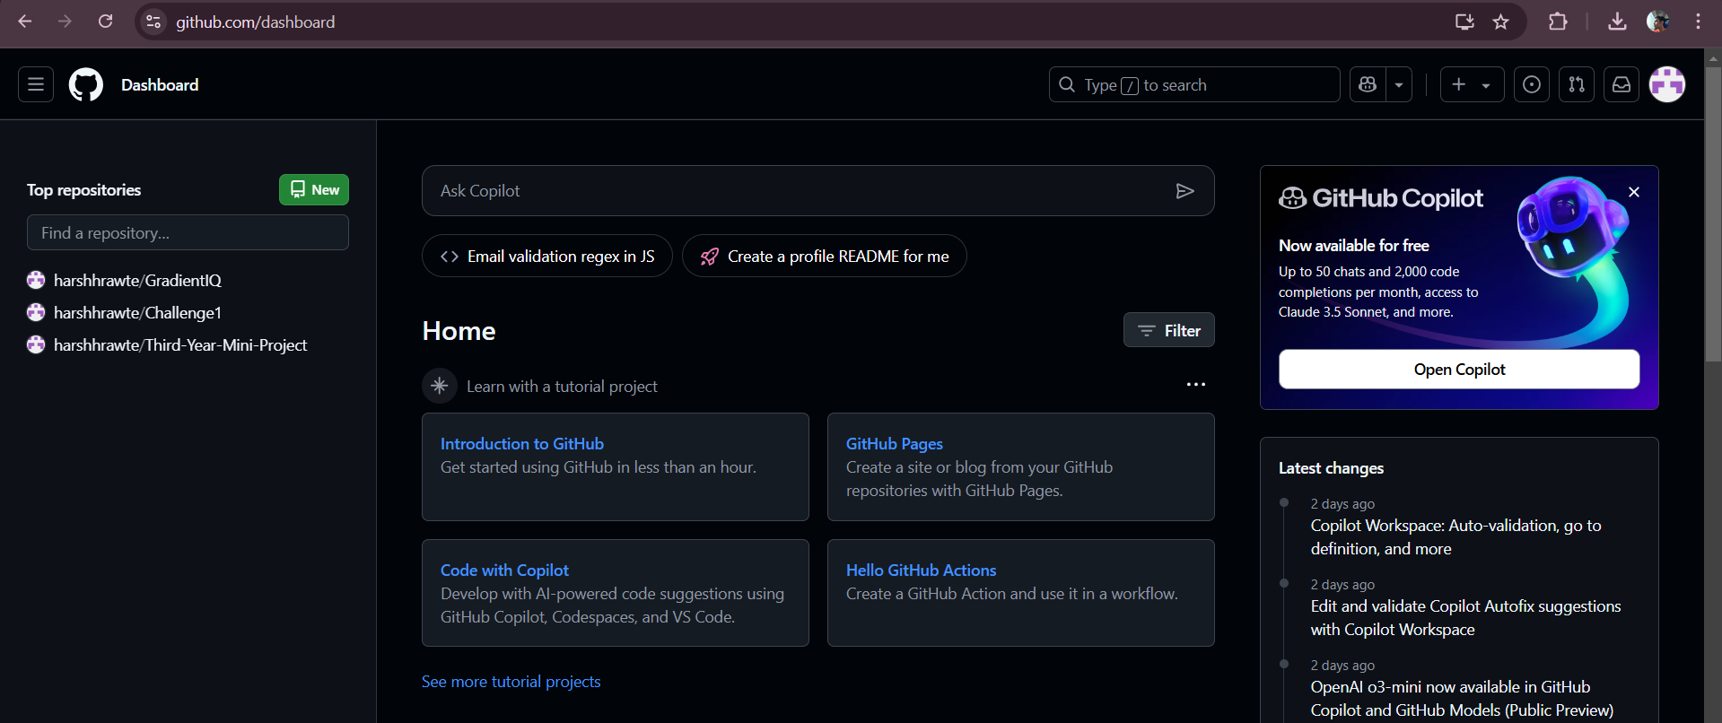
1.5 Push to GitHub
- Set the remote repository URL:
git remote add origin https://github.com/harshhrawte/Third-Year-Mini-Project
- Push the local repository to GitHub:
git push -u origin master

Step 2: Create and Merge Multiple Feature Branches
2.1 Create a New Feature Branch
- Create a new branch for a feature. For example, create a feature-login branch:

git checkout -b feature-login
2.2 Make Changes in the Feature Branch
- Add a new file or modify an existing file in the feature-login branch. For example, modify README.md:

echo "Login feature" >> README.md
2.3 Stage and Commit Changes
- Stage the changes and commit them:

git add README.md
git commit -m "Add login feature to README"
2.4 Push the Feature Branch to GitHub
- Push the feature branch to GitHub:
git push origin feature-login
2.5 Create Another Feature Branch
- Create another branch for a different feature, for example, feature-registration:

git checkout -b feature-registration
2.6 Make Changes in the feature-registration Branch
- Modify the same file (README.md), but with content related to registration:

echo "Registration feature" >> README.md
2.7 Stage and Commit Changes
- Stage and commit the changes:

git add README.md
git commit -m "Add registration feature to README"
2.8 Push the feature-registration Branch to GitHub
- Push the registration branch to GitHub:

git push origin feature-registration
Step 3: Simulate a Merge Conflict and Resolve It
3.1 Switch to master Branch
- Now switch back to the master branch:

git checkout master
3.2 Merge feature-login into master
- Merge the feature-login branch into the master branch:

git merge feature-login
- Since the changes are in different parts of the file, the merge will succeed without conflict.
3.3 Merge feature-registration into master
- Now, try to merge the feature-registration branch:

git merge feature-registration
- Since the feature-registration branch made changes to the same file (README.md) at the same location as feature-login, Git will raise a merge conflict.

3.4 Resolve the Merge Conflict
- Open the README.md file. You will see something like this:

<<<<<<< HEAD
Login feature
=======
Registration feature
>>>>>>> feature-registration

- Edit the file to resolve the conflict. For example, you might combine both features like this:
markdown

Login feature
Registration feature

3.5 Stage the Resolved Conflict
- Once the conflict is resolved, stage the file:
git add README.md
3.6 Commit the Merge
- Commit the merge with a message:
git commit -m "Resolve merge conflict between feature-login and feature-registration"

Step 4: Perform a Pull Request Review and Handle the Integration Process
4.1 Create a Pull Request (PR) on GitHub
- Go to your repository on GitHub.
- You should see a button to create a Pull Request for the branches you've pushed (feature-login and feature-registration).
- Click on "New Pull Request" and select the feature-login branch and compare it with master.
- After reviewing the changes, click "Create Pull Request."
- Add a description of the changes and create the PR.
4.2 Review the Pull Request
- Review the changes in the pull request.
- You can see the changes made and leave comments on specific lines of code if necessary.
- You can ask a team member to review it as well or approve it yourself.
4.3 Merge the Pull Request
- After the PR review, click the "Merge pull request" button.
- Choose "Confirm merge" to integrate the changes from feature-login into master.
4.4 Repeat the Process for feature-registration
- Repeat the same process for the feature-registration branch.
- Create a new PR for feature-registration, review it, and merge it into master.

4.5 Clean Up the Branches
- After successfully merging the feature branches, delete them from GitHub (optional):

git push origin --delete feature-login
git push origin --delete feature-registration

Step 5: Connect GitHub Cloud to Jira
These instructions are for connecting GitHub Cloud or GitHub Enterprise Cloud to Jira. Show me how to connect GitHub Enterprise Server
When you connect a GitHub Cloud organization to Jira, your team can link their development activity to Jira issues. This lets you track branches, commits, and pull requests in the context of your Jira issues, on your Jira board, in the releases feature, and more.

Before you begin
To install and set up the GitHub for Jira app, you need:
- Site administrator permission for your Jira site.
- Organization owner permission for your GitHub organization.
For some organizations, the task of connecting GitHub to Jira might involve multiple team members:
- A Jira site admin will install the GitHub for Jira app.
- A GitHub organization owner will connect a GitHub organization to your Jira site.

5.1 Install the GitHub for Jira app
- In Jira, select Apps, then select Explore more apps.
- Search for GitHub for Jira, then select it from the results.
- Select Get app, then Get it now.

5.2 Connect a GitHub organization
- After the app is installed, select Get started. If the app is already installed on your Jira site, you can find this section by selecting Apps, then Manage your apps, and then GitHub for Jira.
- Select Continue.
- Select GitHub Cloud, then Next.
- Enter your GitHub username and password, then Sign in.
- Find the organization you want to connect to Jira, then select Connect.
To check your permissions for a GitHub organization, open your GitHub organization settings and look for your permission level next to the organization name. Organization owners can review and accept permission requests from Jira in your organization settings. More about required permissions for GitHub for Jira

5.3 Add the Jira app to a new GitHub organization
If no organizations are available to connect to Jira, you’ll need to install the Jira app on a new GitHub organization.
- From step five in the instructions above, Select an organization in GitHub.
- The GitHub site will open in a new tab and show a list of all the organizations available in your GitHub account. Select the organization you want to connect to Jira.
- Choose the repositories you want to give Jira access to by selecting either All repositories or Only select repositories.
- Select Install.
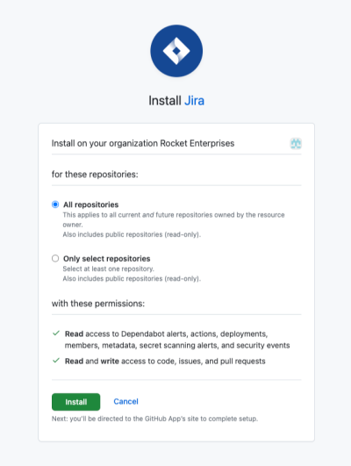

5.4 Connect a new GitHub repository
- If you selected All repositories when you connected a GitHub organization, Jira will be able to access all the repositories in that organization, including any new repositories you create.
- If you selected Only select repositories, any new repositories you create won’t be added automatically. Here’s how to add them:
- In Jira, select Apps, then select Manage apps.
- In the sidebar, under GitHub for Jira, select Configure.
- Find the organization that contains the repo you want to add and select the three-dot menu (…) to view available actions.
- Select Configure.
- A new tab will open with your GitHub organization settings. Under Repository access, select the dropdown Select repositories.
- Select the repository you want to connect to, then Save.
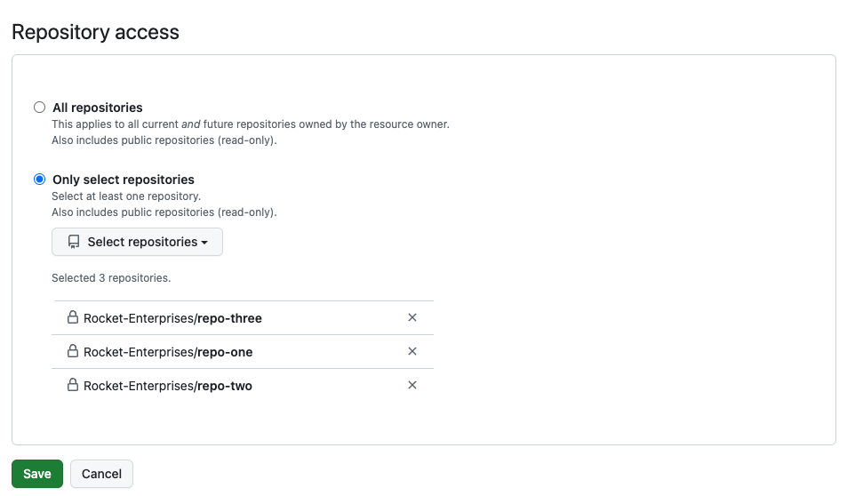
If you use IP allowlists in your GitHub organization, you might have issues using GitHub for Jira, even if the correct IP addresses are in your IP allowlist. Here’s the workaround: How to update your GitHub IP allowlist configuration
Still need help? Raise an issue with our team.

5.5 Link your development information to Jira issues
To link branches, commits, and pull requests to Jira, your team must include Jira issue keys in their development actions.
- Find the issue key for the Jira issue you want to link to, for example “JRA-123”. You can find the key in several places in Jira:
• On the board, issue keys appear at the bottom of a card.
• On the issue’s details, issue keys appear in the navigation at the top of the page.
- Check out a new branch in your repo, using the issue key in the branch name. For example, git checkout -b JRA-123-<branch-name>.
- When committing changes to your branch, use the issue key in your commit message to link those commits to the development panel in your Jira issue.
For example, git commit -m "JRA-123 <summary of commit>".
- When you create a pull request, use the issue key in the pull request title.
- After you push your branch, you’ll see development information in your Jira issue.
How to use the GitHub for Jira app
- Link GitHub development information to Jira issues
- Link GitHub workflows and deployments to Jira

Post lab exercise:
Instructions:
- Initialize a Git repository and push it to GitHub.
- Create and merge multiple feature branches.
- Simulate a merge conflict and resolve it.
- Perform a pull request review and handle the integration process.

1. Initial Setup:
Each developer should clone the repository and create a feature branch as instructed.
# Clone the repository
git clone https://github.com/TechCo/your-repo.git
# Navigate into the project directory
cd your-repo
# Create a feature branch
git checkout -b feature/john-does-feature
Developer 1 and Developer 2 should create separate feature branches based on the above instructions. For example:
- Developer 1 creates the branch: feature/john-feature
- Developer 2 creates the branch: feature/jane-feature
- Paste the Output here:

2. Collaborative Changes:
Both developers will make changes to the same file (app.js), but in different parts of the code.

Developer 1's changes:
// Modify a function in app.js
function greetUser() {
console.log("Hello, user!");
console.log("Welcome to TechCo's new app.");
}
Commit the changes:
git add app.js
git commit -m "Add greeting message for new users"
git push origin feature/john-feature

Developer 2's changes (on the same line):
// Modify the same function in app.js
function greetUser() {
console.log("Hello, user!");
console.log("We hope you enjoy using TechCo's app.");
}
Commit the changes:
git add app.js
git commit -m "Update greeting with a new message"
git push origin feature/jane-feature

- Paste the Output here:

3. Merge Conflict:
Once both developers have pushed their changes, it’s time to merge their feature branches into main. This will result in a merge conflict since both developers modified the same lines of code in app.js.

Steps for Merging and Resolving the Conflict:
- Switch to the main branch:
git checkout main
git pull origin main # Fetch the latest changes from the main branch
- Try merging one of the feature branches into main (e.g., Developer 1’s branch):
git merge feature/john-feature
- At this point, Git will notify that a conflict exists in app.js. The conflicted file will be marked as having conflicts. To resolve it:
- Open app.js in a code editor. You will see something like this:
function greetUser() {
console.log("Hello, user!");
<<<<<<< HEAD
console.log("Welcome to TechCo's new app.");
=======
console.log("We hope you enjoy using TechCo's app.");
>>>>>>> feature/jane-feature
}
- The conflict markers (<<<<<<<, =======, >>>>>>>) indicate where the conflict occurs. You need to decide which version to keep or how to merge the changes. Here’s how you can resolve it:

function greetUser() {
console.log("Hello, user!");
console.log("Welcome to TechCo's new app.");
console.log("We hope you enjoy using TechCo's app.");
}
- After resolving the conflict, remove the conflict markers and save the file.
- Add the resolved file and commit the changes:
- git add app.js
git commit -m "Resolve merge conflict in app.js"
git push origin main
Paste the Output here:

4. Rebasing Practice:
Now, Developer 1 and Developer 2 will fetch the latest changes from the main branch and rebase their feature branches onto main to ensure that their code is up-to-date.

Developer 1 Rebasing:
# Fetch the latest changes from the main branch
git fetch origin
# Rebase the feature branch onto main
git rebase origin/main
# Resolve any conflicts if necessary, following the same conflict resolution process above
# After resolving conflicts, continue the rebase
git rebase --continue
# Push the rebased branch
git push origin feature/john-feature --force

Developer 2 Rebasing:
Developer 2 will repeat the same steps to rebase their branch.
git fetch origin
git rebase origin/main
git rebase --continue
git push origin feature/jane-feature --force

5. Reviewing Commit History:
Once the merge and rebasing are complete, both developers should inspect the commit history to ensure that their commits are clear and meaningful.
git log --oneline --graph
Ensure that each commit message follows a clear and consistent format, e.g., "Fix bug in the greeting function" or "Add new user welcome message."

6. Final Task: Creating Pull Requests (PRs):
- Developer 1 and Developer 2 should now open pull requests on GitHub to merge their feature branches into the main branch.

Developer 1's PR:
- Title: Merge feature/john-feature into main
- Description: "Added a new greeting message for first-time users."

Developer 2's PR:
- Title: Merge feature/jane-feature into main
- Description: "Updated the greeting message to include additional text for users."
Once both pull requests are reviewed by the team, they can be merged into the main branch.

Conclusion: By following these steps, the developers will:
- Learn how to resolve merge conflicts effectively.
- Practice using rebase to keep their branches up to date with main.
- Understand how to maintain clean commit histories and write meaningful commit messages.
- Gain hands-on experience with Git workflows that are crucial for collaborative development.

